**Q1:**

A stabilizable system will reach the desired state for a control input . If the a system is not stabilizable no minimum of the LQR problem can be found since the state cost will increase continuously.

A reachability test could be performed since a reachable system is also stabilizable. Reachability is a necessary condition for stabilizability. Therefore, the full rank of the controllability Matrix or the PBH test is to be checked.

The PBH test for reachability is performed: A system (A, B) is unreachable if and only if there exists a left hand eigenvector with such that

and .

The calculation delivers the following eigenvalues:

As a result, the system is reachable and since the reasoning above it’s also stabilizable.

**Q2:**

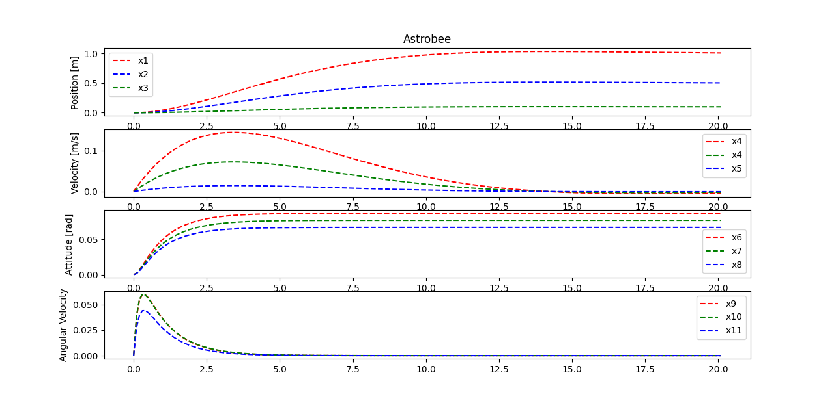

Figure : Astrobee states over simulation time

**R = 10:**

By multiplying the R matrix by factor 10 the control input is penalized stronger so that smaller control values are calculated. As a result, it the time to reach the desired states is increased since the focus is on low control input, see figure 2.

Ein Bild, das Text, Reihe, Diagramm, Screenshot enthält.

Figure : Astrobee with R = 10

**Q[3:6] = 100 and Q[9:] = 100:**

By increasing the two single Q entries…

**Ein Bild, das Text, Reihe, Diagramm, Screenshot enthält.
**

Figure : Astrobee with Q[3:6] = 100 and Q[9:] = 100

**Penalization of position and attitude with 100:**

By high penalization of position and attitude these state are reach in short time, since in minimum ins only found if these variables are reaching their desired state as fast, see figure 4.

Ein Bild, das Text, Reihe, Diagramm, parallel enthält.

Figure : Astrobee with 100 penalized position and attitude

**Q3:**

The requirements are met by the following weighting matricies:

For the weights of the Q-Matrix we found:

The following requirements are fulfilled, see also figure 5:

* Max distance to reference:
* Max speed:
* Max forces:

* Max torques:
* Max Euler angle deviations: (
* Overshoot

fullfilled

*Ein Bild, das Text, Reihe, Diagramm, parallel enthält.
*

Figure : Astrobee with multioptimized states and constraints

**Q4:**

The performance of the controller is influenced measurement noise now. The matrix is the input of this measurement noise for the Kalman filter. Small position deviations are detected, see Figure 6.

Ein Bild, das Text, Reihe, Diagramm, parallel enthält.

Figure : Astrobee with measurement noise: No huge deviations

To find out more about the influence of the measurement noise on the control, the measurement noise is increased from (-0.1, 0.1) to (-1, 1). It results in a highly disturbed position and velocity states that do not meet the requirements anymore. For example, the requirement of a maximum deviation of 2 cm on the position for the time after 12 sec does not hold anymore. Also the control effort is much higher because the system does not stabilize on one value and has to be controlled always to tend to the reference state.

Ein Bild, das Text, Diagramm, Reihe, parallel enthält.

Figure : Astrobee with high measurement noise of amount (-1,1): huge deviations in position and speed

**Q6:**

Now process noise is included to make the system more realistic. The matrix represents the process noise for the Kalman filter, see Figure 7.

Ein Bild, das Text, Diagramm, Reihe, parallel enthält.

Figure : Astrobee with measurement noise of given distribution of (-0.05, 0.05) and & factorized with 1

By increasing the measurement noise, the deviations get more severe, but the system still stays stable, see Figure 8.

Ein Bild, das Text, Diagramm, Reihe, parallel enthält.

Figure : Astrobee with estimated position, measurement noise of (-0.1, 0.1) and & factorized with 10